**SOFWARE TESTING ASSIGNMENT**

Module – 1 (Fundamental)

* **What is SDLC**

A software development Life cycle (SDLC) is essentially a series of steps, or phases, that provide a modal a modal for the development and life cycle management of an application or piece of software.

* **What is software testing?**
* Software testing is a process used to identify the correctness, completeness, and quality of developed computer software.

when asked, people of ten think that testing only consists of running tests.

* Executing the software test execution is only apart to testing, but not all of the testing activities.
* **What id Agile methodology?**

The combination of iterative and incremental modal.to focus on a process adaptably and customer satisfaction by rapid delivery of working software product.

**Advantages**

* Suitable for big project.
* Product is developed fast and frequently delivered (weeks rather then months.)
* Flexibility to adapting.

**Disadvantages**

* it is not useful for small projects.
* Depends heaving on customer interaction.
* Cost of agile development methodology is costly.
* **What is SRS**

A software requirements specification (SRS) is a documents that describe what the software will do and how it will be expected to perform.

* **Write SDLC phases with basic introduction**

Developments process there are 6 phases in SDLC modal.

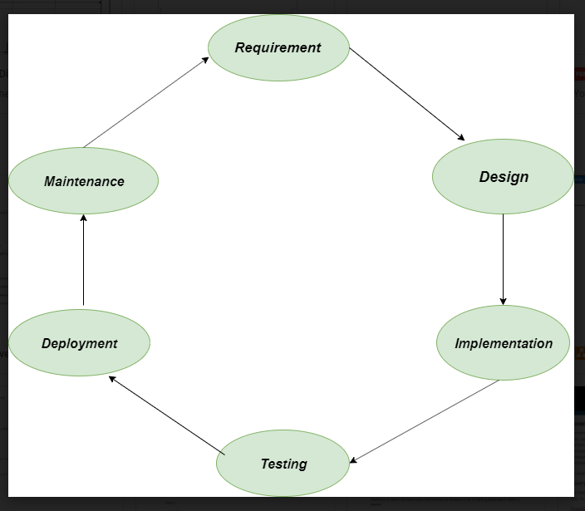

1. **Requirements**

In this phase,all the requirements are collected from the customer/client. They are provided in a document called businessmen requirement specification (BRS) and system requirement specification (SRS).

* All the details are discussed with the customer / client in details.

1. **Design**

It has two steps:

**High – level design** (HLD) : it given the architecture of software products.

**Low – level design** (LLD) : it describes how each and every feature in the product should work and every component.

1. **Implementation**

This is the longest phase

* Front – end : development of coding is done
* Middleware : they connect both the front end and back end.
* Back – end : a database is created.

1. **Testing**

Testing is carried out to verify the entire system.the aim of the tester is to find out the gaps and defects within the system and also to check whether the system is running according to the requirement of the customer / client.

1. **Deployment**

After successful testing,the product is delivered / deployed to the client,the even clients are trained on how to use the product.

1. **Maintenance**

Once the product has been delivered to the client a task of maintenance starts as when the client will come up with an error the issue should be fixed from time to time.

* **Explain phases of the waterfall modal**

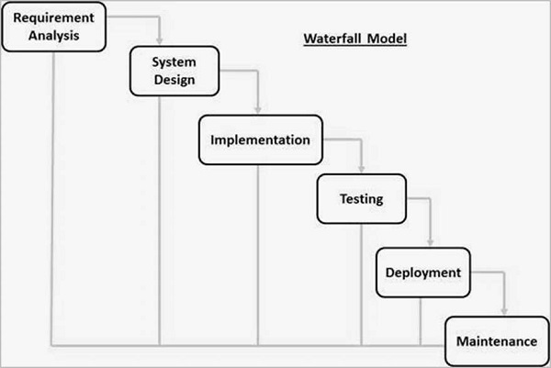

1. **Requirements analysis**

All possible requirements of the system to be developed are captured in this phase and documented in a requirement specification document.

1. **System design**

the requirement specifications from first phase are studied in this phase and the system design is prepared.

1. **Implementation**

With inputs from the system design,the system is first developed in small programs called units,which are integrated in the next phase.each unit is developed and tested for its functionality,which is referred to as unit testing.

1. **Testing**

All the units developed in the implementation phase are integrated into a system after testing of each unit.

1. **Deployment**

Once the functional and non-functional testing is done the product is deployed in the customer environment or released into the market.

1. **Maintenance**

There are some issues which come up in the client environment.to fix those issues, patches are released.

* **Phases of spiral modal**

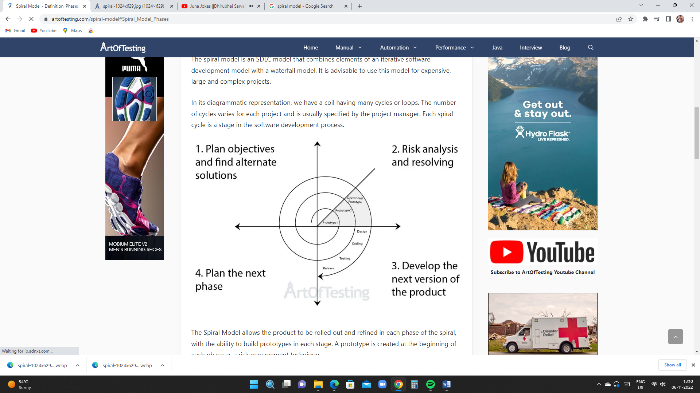

It has four stages or phases.

1. **Plan objectives and find alternate solutions**

This phase includes requirement gathering and analysis.

* **Usecase online book shopping**

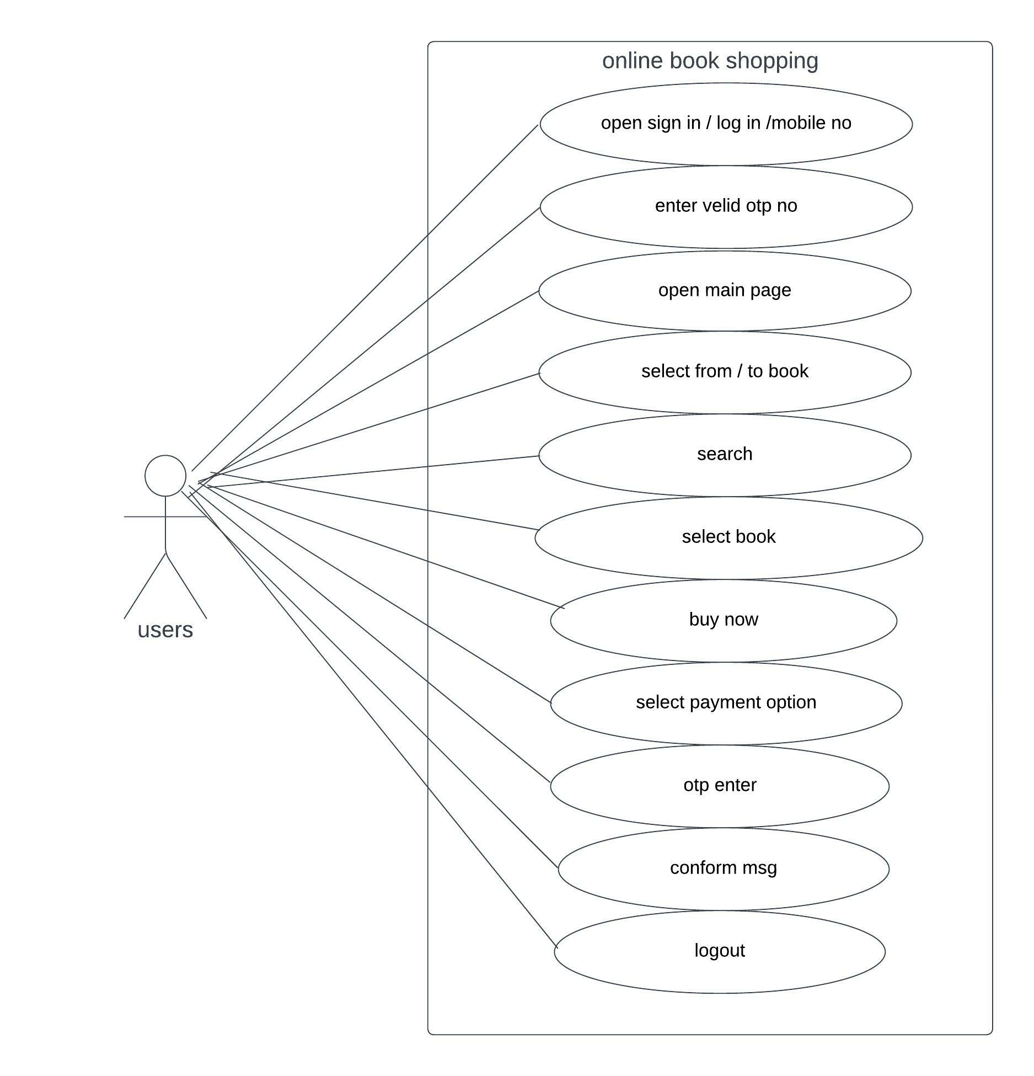

* **Usecase online bill payment system (paytm)**

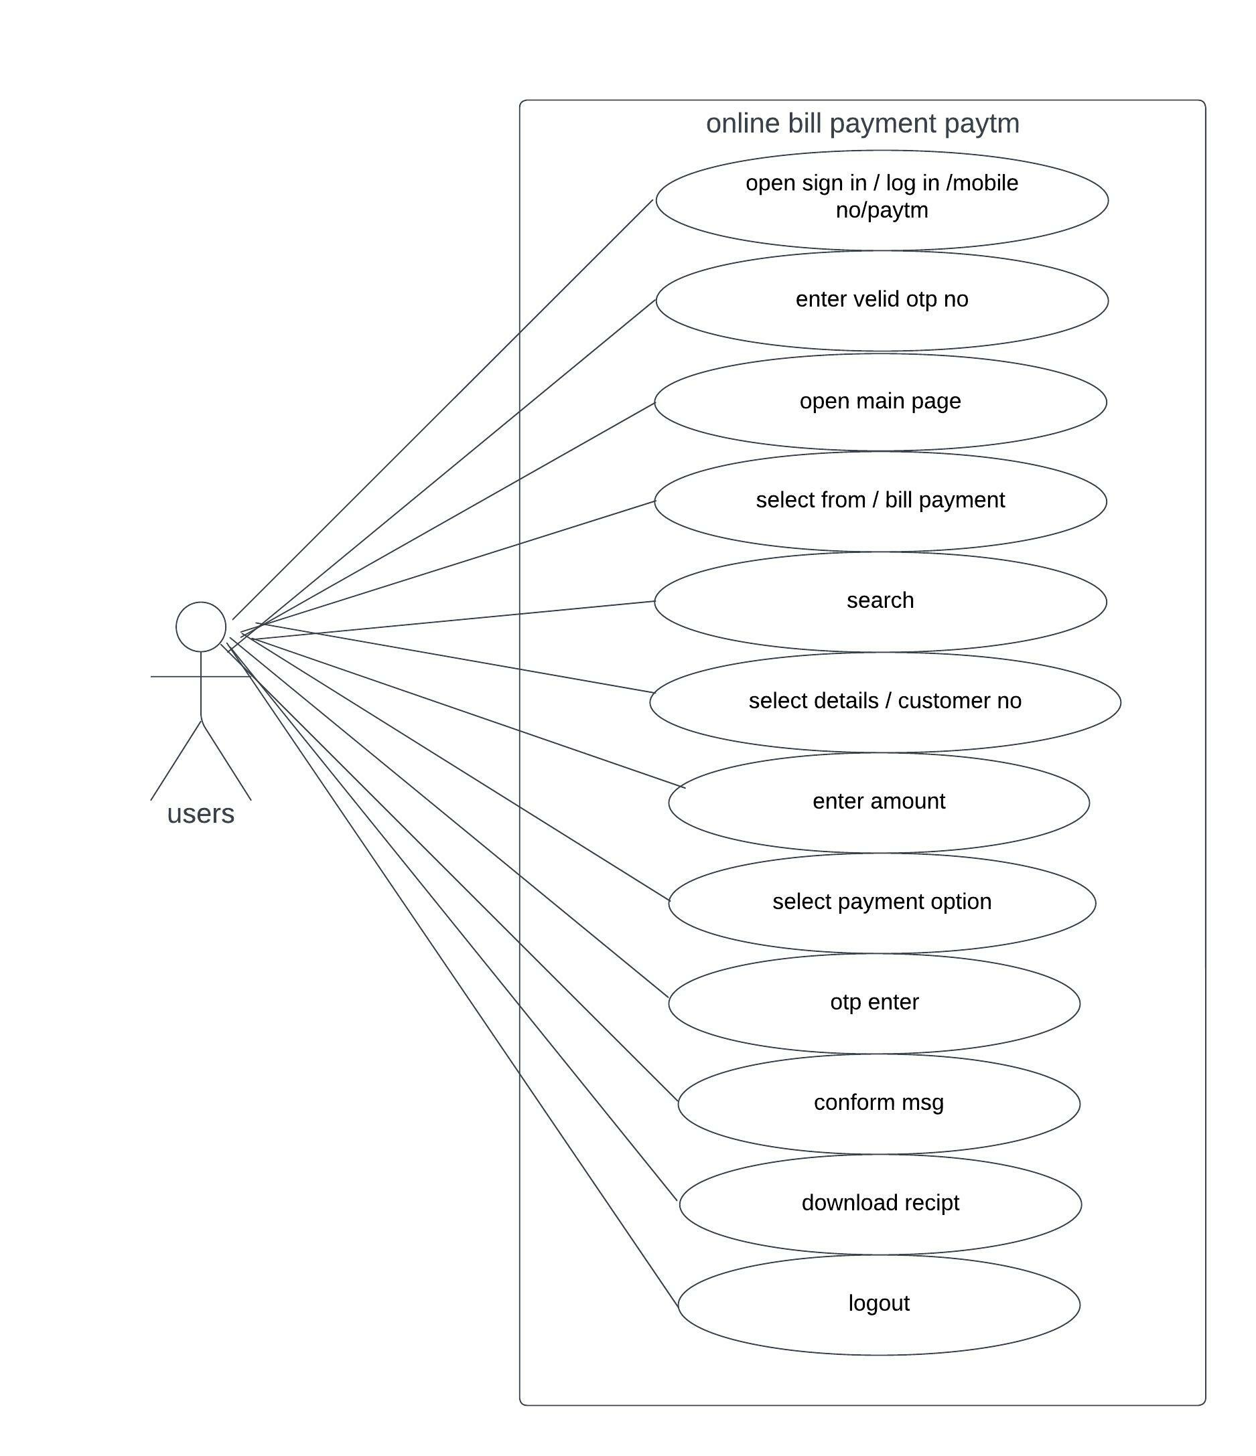

* **Usecase on online Mobile shopping product COD.**

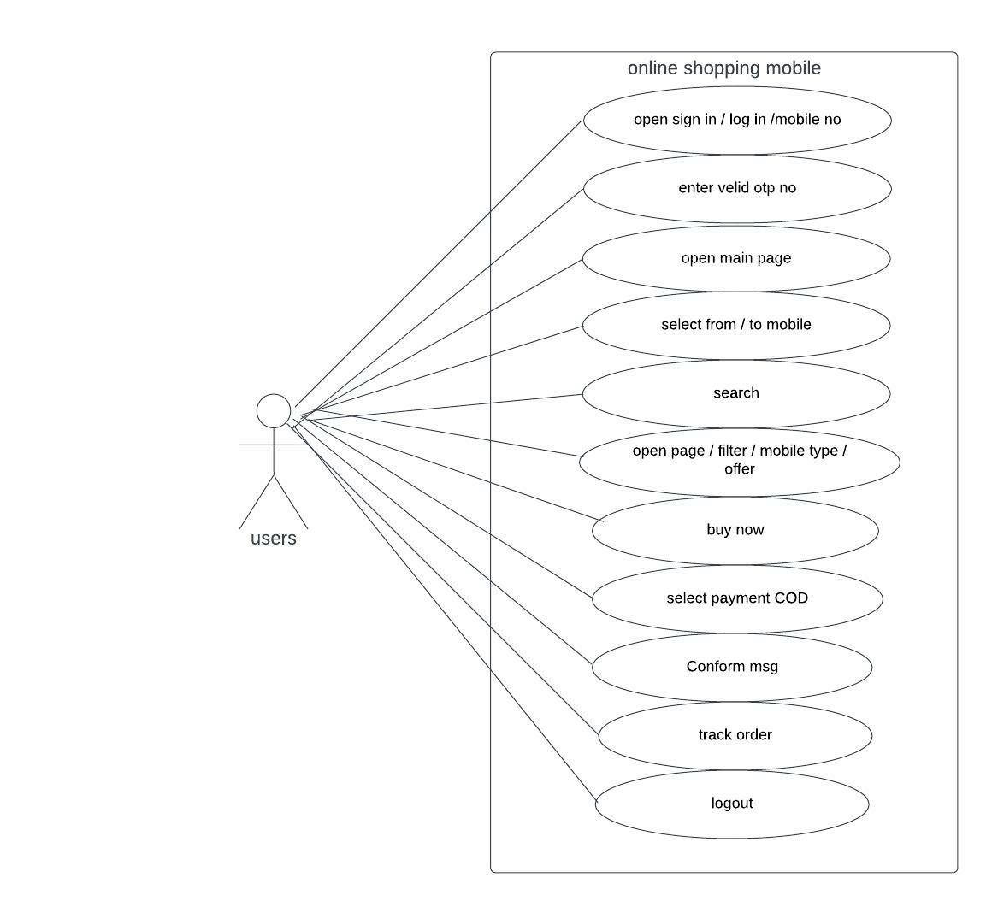

* **Usecase on online Tv shopping product payment gateway.**

